Shabbos Stories for
Parshas vayechi 5782
Volume 13A, Issue 17 - 14 Tevet/December 18, 2021
Printed L’illuy nishmas Nechama bas R’ Noach, a”h

For a free subscription, please forward your request to keren18@juno.com
Past stories can be found on the website ShabbosStories.com

The Ponevezher Rav and
The Seven-Year-Old Boy

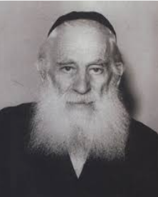

The Ponevezh Yeshivah in Bnei Brak is one of the world’s most distinguished Yeshivos, and gaining entrance to the Yeshivah is not simple. A Yeshivah student must have exceptional ability in his learning, and have tremendous dedication to achieving excellence.
It was, therefore, quite surprising when a young teenage boy from Switzerland, whose level of proficiency was lacking, insisted on meeting the Rebbetzin, the widow of the Yeshivah’s founder, Rav Yosef Kahaneman, zt”l, the Ponevezher Rav.
The Rebbetzin did not have an active role in the Yeshivah’s admission process, and the Ponevezher Rav had already passed away a few years earlier. The entire meeting did not make sense. The boy, however, persisted, and asked to meet with the Rebbetzin. He was guided to the Rebbetzin’s apartment, met with her for a few moments, and then emerged with a big smile across his face.
The Rebbetzin then asked to speak with the present Rosh Yeshivah. A few minutes went by as the elderly widow met with the Rosh Yeshivah, and shortly after, the Rosh Yeshivah motioned for the young student to come over. He said, “Welcome to the Ponevezher Yeshivah!”

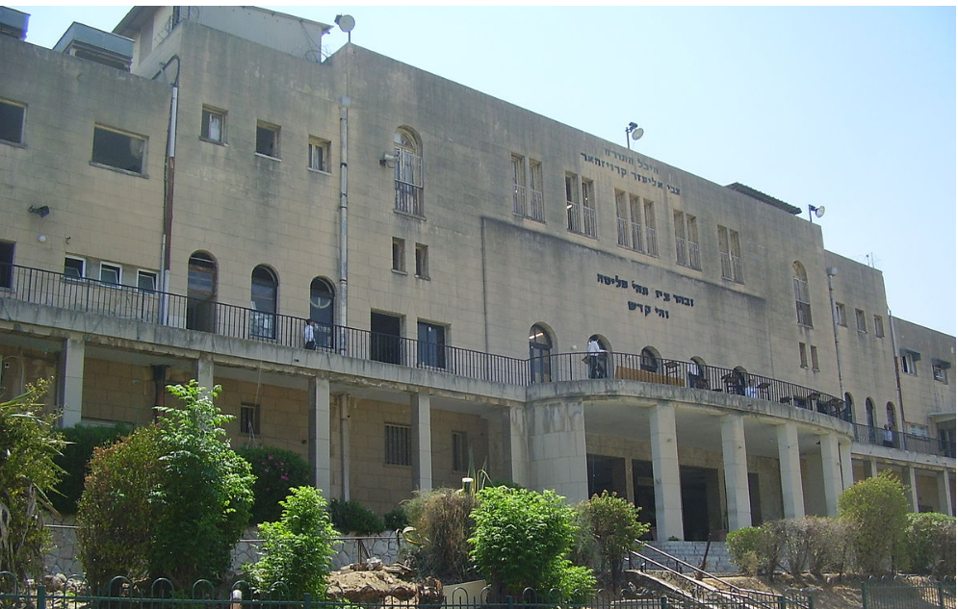
Photo of the Ponevezher Yeshiva in Bnei Brak, Israel

Everyone, especially the other students who had observed the entire incident, was clueless to what had taken place. The young boy explained to them that he had an arrangement with the Ponevezher Rav. He explained, “When I was seven years old, one summer, I vacationed with my mother in Switzerland. Coincidentally, the Ponevezher Rav was also staying at this hotel, as it was the only Kosher establishment in the area.
“The only available room for the Ponevezher Rav was on the top floor, but it was very difficult for the Rav to walk up and down the flights of stairs. When my mother heard of this problem, she immediately offered to switch rooms with the Rav, because we had a room on the ground floor. The Ponevezher Rav graciously accepted the offer, but insisted that I give my permission as well, which I gladly did. “Afterwards, he invited us to his room and said to my mother, ‘I want to express my gratitude to you for your kindness. I know that when one is on vacation everyone wants everything to go as planned, and I would like to buy your son a toy as a token of my appreciation.’
“I immediately interjected and said, ‘Please, I do not want a toy. I do not even want a few coins. I would like only one thing, to one day to be a student at the Ponevezher Yeshivah.’ The Rav smiled and took out his pen, and wrote a note on the hotel stationery, that I was accepted as a student in Ponevezh. And that is why I needed to speak with the Rebbetzin today, so I could show her the letter of acceptance I had from the Ponevezher Rav!”

Reprinted from the Parshas Mikeitz 5782 email of Rabbi Yehuda Winzelberg’s Torah U’Tefilah

What Is Mesiras Nefesh?
By Rabbi Sholom DovBer Avtzon

In the Al Hanissim that we say on Chanukah, it is mentioned that on paper the Chashminoim (Maccabees) had no chance of winning the war. The Greeks were stronger and outnumbered them. Yet the Jews did not make this calculation, nor did they rely on the law that if there is only impure oil, it can be used. They searched and searched until they found a single jug of pure oil.
Going beyond the letter of the law, is called mesiras nefesh. So, I will post a story about Mesiras nefesh that I heard at a farbrengen of Rabbi Nissim Mangel sheyichye.

When the Tzemach Tzedek (Rabbi Menachem Mendel Schneersohn, 1789-1866, the third Rebbe of Chabad) returned from the Rabbinical Conference of 5603 (1843), the chassidim spoke in awe of his steadfast mesiras nefesh. How even after being arrested twenty-two times in a period of a few months, he wasn’t intimidated and didn’t cave in to the pressure and threats of the government of being charged of treason.
The Rebbe heard this and said that was not mesiras nefesh as I did it to protect the Torah. Reb Boruch of Mezibuzh (1753-1811, grandson of the Baal Shem Tov) had real mesiras nefesh. The Rebbe then proceeded to relate the following story:
There was a chossid of Reb Boruch who sold wine. He borrowed money and bought a few barrels of wine, loaded them up on his wagon and went from village to village selling smaller amounts to each customer. After selling what he had, he returned home, paid off his creditors, paid his family’s debts and once again bought on credit and some loans.
One Thursday night as he was saying krias shema before going to sleep, he contemplated his actions of the day (and of the last few weeks) and felt that his actions and conduct are not the way they should be for a Jew and especially a chossid of the great tzaddik Reb Boruch.

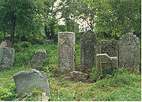
The Jewish cemetery in Mezibuzh where Reb Boruch of Mezibuzh is buried next to his grandfather – the Baal Shem Tov.

Being that he fortunately was close to Mezibuzh he decided to spend the Shabbos by his Rebbe. Hopefully he will be allowed to ask the tzaddik how he can correct his flaws. He received permission from the innkeeper to leave his wagon in the stable over Shabbos, and off he went to his Rebbe.
Friday night the chassidim would come to the Rebbe’s tish to hear his explanations or thoughts on some aspects of the weekly parsha and be inspired. This week, however, in front of everyone, Reb Boruch berated the chossid for leaving his wagon in the inn without proper supervision. What were you thinking, asked Reb Boruch.
The chossid was humiliated, but accepted it, thinking, most probably the Rebbe did this to atone my flaws.
However, during the meal on Shabbos day and during the third meal late Shabbos afternoon as well, the Tzaddik Reb Boruch continued to berate and embarrass this chossid.
It came to a point that another guest who happened to be related to the Rebbe couldn’t contain himself anymore and said to Reb Boruch, my dear mechutan our sages tell us whoever shames a person in public has no portion in the world to come, and you did so on three occasions.
Reb Boruch replied, Mechutan, don’t you think that I am aware of that statement, but what was I to do?
This chossid in his sincerity came to seek guidance and left his wagon with barrels of wine in the barn of the inn in a nearby village. The inn has many customers and some of them noticed that this wagon was left unattended and were discussing among themselves that it is a golden opportunity to enjoy the wine, after all it is on the house.
If that would have happened, this chossid would have been financially ruined. He would not be able to pay off his debts, the wholesalers wouldn’t trust him anymore, and he would lose his source of income.
So, I decided to humiliate and indeed mortify him. The anguish that he received from this equaled the anguish he would have experienced had his wine been enjoyed by those customers in the inn and been left without a source of income. By doing this heaven decided that he should not have additional anguish and caused that the other people in the inn left his barrels alone.
I am willing to forgo and lose my share in the world to come if that prevents a single Jew from losing his livelihood.

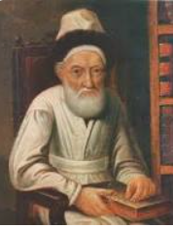
Tzemach Tzedek

That concluded the Tzemach Tzedek is mesiras nefesh, but what I did was for the entire Jewish nation as well as for the honor of the Torah, and that is something anyone would have done, no matter the price he would have to pay.

Reprinted from the Parshas Mikeitz 5782 Weekly Story email of Rabbi Sholom DovBer Avtzon who is a veteran mechanech and the author of numerous books on the Rebbeim of Chabad and their chassidim. He can be contacted at avtzonbooks@gmail.com

The Sensitivity of Rav Moshe
By Rabbi Dovid Goldwasser

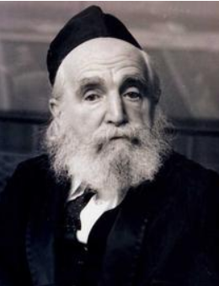
The great posek hador, HaGaon HaRav Moshe Feinstein, was renowned for his extreme kindness and sensitivity for others.
After attending a very important meeting of the leaders of the generation, R’ Moshe left early for a wedding. Upon his arrival, R’ Moshe went over to the father of the chosson, and gave him a warm mazel tov, accompanied with many heartfelt brachos. He then explained that the kallah was a relative of his, who was indeed a very special member of the family, and he was happy to be able to join the simcha.
R’ Moshe was seated at the head table, where a line soon formed of people who wanted a bracha from the gadol. They all introduced themselves and expressed their delight in discovering that the great R’ Moshe Feinstein was related to the family.
R’ Moshe sat patiently, greeting and blessing each well-wisher until the new couple rejoined the guests. R’ Moshe danced with the chosson, and then praised the kallah and her wonderful middos. As he prepared to leave, R’ Moshe spoke to the kallah, and gave her heartfelt brachos as well.

Certain Things that One Must Do
As they rode home, R’ Moshe wearily commented to his driver, “I don’t have too much time to sleep, but there are certain things that one must do.”
Since the Rav had definitely implied earlier that he was not related nor was the chosson his disciple, the driver asked R’ Moshe why he had attended the wedding. R’ Moshe told him that the kallah had come to his home while he was learning, and after requesting a bracha from the gadol, asked if he could come to the wedding and introduce himself as a member of her family. She explained that she came from a penniless family in Yerushalayim, and there was no one here in America from her side who would be in attendance at the wedding.

R’ Moshe was unsure at first how he could say an untruth. But he

then applied the precept of our Sages that there is no member of the Jewish Nation who does not have a “redeemer,” i.e., a relative who can redeem him. He therefore told the kallah that he could qualify as a relative, even if a distant one, and he promised to come to the wedding.
Incredulous, the driver asked why he had to stay so long at the wedding.
“The kallah requested my presence. It was very important to her that I come. In a few hours the wedding will be over, but the great happiness of tonight will last for a lifetime. It was worthwhile for me to give up one hour of my time for a chosson and kallah to share a lifetime of joy together,” said R’ Moshe.

Reprinted from the Parshas Vayeishev 5782 website of The Jewish Press.

The Benefits of Being Mevater

Accepting rebuke – owning up to the error of one’s ways, bowing to disappointment – is the mark of an honourable person. Horav Yitzchak Zilberstein, Shlita, relates the story of a young Torah scholar who lived in a block of flats in central Eretz Yisrael.
Someone opened up a children’s shop on the first floor of the building which sold all kinds of products geared to the infant through to teenage market. They also carried children’s furniture, cots, prams, etc.
In order to attract attention to their wares, the shop’s owner placed some of his products outside of his shop for passers-by to notice. Everything seemed perfectly innocent – except to the young scholar, who took umbrage with a business using the pavement in front of his block of flats for advertisement purposes.
When the owner of the store ignored his complaints, he presented his grievance to a bais din. The bais din listened to his complaints and even dispatched one of their own to look at the furniture on the street but found no reason to ban this form of advertisement. Case closed.
The Torah scholar, who was a decent, upstanding ben Torah, accepted the halachic ruling. The Av Bais Din, head of the court was impressed with the young man, went over to him and whispered in his ear, “You did well and acted appropriately. Who knows? One day you might benefit from the services of the storekeeper or his products.”
Ten days passed, and the young man and his wife were in the kitchen of their fourth floor flat, when their two-year-old crawled out onto the balcony and somehow squeezed between the bars of the balcony and fell down. The parents heard their child’s shriek, and they came running.
Overwhelmed with shock, they imagined the worst. They looked down from their fourth floor perch expecting to witness a tragedy. Hashem had protected their child, who landed on the mattress of the crib outside of the children’s store!
It was as the Av Bais Din had portended: The young man was the beneficiary of his own honorable willingness to accept the halachic ruling of the Bais Din. The young scholar was mevater, manifested self-control, and acted royally by accepting the ruling.
Horav Elozar M. Shach, zl, declared that in his entire life, he had never seen someone who was mevater and lose out as a result of his concession. The young Torah scholar and his child present a living testament to this verity.

Reprinted from the Parshas Vayeishev 5782 email of Rabbi A.L. Scheinbaum’s Peninim on the Torah.

The Boy with His Feet
On a Pile of Chumashim

A veteran Mashgiach once spoke at a chinuch convention about responding to a case of severe misconduct. He told the following story: “I used to be the Mashgiach in a yeshivah where many of the boys came from weaker homes and were making their way in Yiddishkeit.
Once, in the middle of a shiur, I noticed one boy resting his feet on a pile of Chumashim that were on the chair in front of him, with a slightly defiant look on his face. My instinctive feeling was to unleash a good tongue-lashing. Boruch Hashem, I caught myself in time.
Yes, he was being a wise-guy, but it wasn’t much more than that. Considering where this boy came from, the behavior wasn’t shocking. He hadn’t been raised to treat seforim with reverence, so it was natural enough for him to do what he did without really appreciating its severity. In addition, he was a very sensitive boy, and coming under attack would likely have caused him serious harm.

Unable to Ignore It
On the other hand, I couldn’t ignore it. “As I hesitated, other boys noticed, and they motioned to him to take his feet off. The boys looked at me apprehensively, to see how I’d react. By not reacting, I would cause them to take the matter lightly. I closed my eyes as I tried to think of a solution. There was a tense silence. Everyone was waiting for me to respond, and I simply didn’t know how. Then, I had a brainstorm, B”H. I opened my eyes and said, ‘I cannot continue this shiur. I don’t think I’m qualified to do so. I see that I’ve been on the wrong track in my chinuch approach. I have to correct my errors, and I’m going to do it right now.’
The boys were in shock. They stared at me with wide eyes and bated breath. The boy himself also looked very tense. “I continued to speak. ‘This is my fault. The boy who did this isn’t aware of how severe it is. But I should have taught him about this. Instead of speaking about lofty ideas, I should have first taught the basics of the lifestyle and behavior of a ben Torah. So, I am stopping this shiur, and I am committing, bli neder, to fast for a day in order to atone for what happened.’

The Rosh Yeshivah Also Stood Up
I closed the sefer I was reading from and began heading out. The Rosh Yeshivah, who had been sitting on the side watching, also stood up and said, ‘I share the responsibility. I am also going to fast for a day, bli neder.’
“Never before did I fast with such an inner sense of joy. The impact this had on the boys was wonderful. It was the talk of the yeshivah, and the boys clearly took it very much to heart. But even more special was the effect that this “punishment” had on the boy who had done it. He tried to assume the guilt himself and convince me not to fast.
I rejected his arguments, but he persisted, saying that even if it was my fault, he also shared the blame, so I need to also provide him with some form of atonement. Knowing how sensitive this boy was, I was nervous about causing him to feel guilty. However, I did believe that, since he had initiated the request, he could handle it.

Made a Suggestion that He Make a
Commitment to Be More Careful
So, I accepted his argument, and suggested that he undertake to be very careful about the honor of the Beis Medrash. From that day, we no longer needed hired help to keep the Beis Medrash in order. This boy’s dedication to his new job was amazing. The Beis Medrash always stayed clean and neat all day, every day.
Even years later, when I was already teaching somewhere else and returned to visit the yeshivah, I found the Beis Medrash very neat and clean. It had turned into something of a tradition that keeping the Beis Medrash clean was a position of prestige.” (Adapted Excerpt from “Spare the Child” by Rabbi Yechiel Yaakovson)

Reprinted from the Parshas Vayeitzei 5782 email of Rabbi Dovid Hoffman’s Torah Tavlin.

The Power of Your Neshama
By Rabbi Yaakov Rahimi

There was a Rosh Yeshiva who had come to America to collect money in the New York area. To assist the Rosh Yeshiva in efforts, a driver was hired to bring him around to the various houses and office buildings, in which he would meet with different individuals interested in supporting his yeshiva. For years, this same driver was hired to chauffeur the rabbi around, though when the pandemic broke out, the rabbi was forced to stop his travels. It was only over a year later that he made his way back to the states.

When the Rosh Yeshiva met the driver again more than a year later, he was taken aback. The driver, who previously was not religious at all, was now wearing a yarmulke, tzitzit, and as he soon revealed, kept Shabbat too. The driver began detailing the story that brought him to this point.

A couple months back, I received a call from a non-Jew who said that he wanted me to drive him six miles out to a forest. “Drop me off,” he added, “leave, and then come back for me.” This was a strange request, but I figured that he just wanted me to do as he said, and I saw it as a good opportunity. So, I complied.

The day we arranged, I picked him up and started driving six hours out. We arrived at a certain place which was no less than a forest. I began to wait nearby, until suddenly, I heard a knock on the side window. It was the man I had just dropped off. “Listen,” he said, “I need you to drive ten miles out. Don’t ask me any questions. Just drive.” I listened.

An hour later, I received a call from the fellow who asked me to pick him up. I returned to the forest, picked him up and began making my way back. Thinking about what had just transpired, I couldn’t wrap my head around it. What was this all about. So, I turned around for a moment, looked at my customer and asked him. “I know it’s not really business-like to inquire into your private affairs, but if you are able to, could you tell me what this is all about? Why did you ask me to drive six miles out, then drive ten miles away?”

“Let me tell you,” the man replied. “Unfortunately, I’ve been diagnosed with cancer and the doctors have completely given up hope on me living. After I heard this, I became desperate. I needed to find some way to stay alive. I don’t want to die! So, I began looking into psychics and those who are familiar with black magic. I was given this information about this fellow who lives in this forest, and is a black magic guru. He is known to be one of the best, and has proven helpful in curing people of their illnesses. It costs thousands of dollars, but it gets the job done. So I thought to myself, ‘I have nothing to lose. I’ll drive six hours out, pay someone whatever price he asks, and hope that it can help me.’ That is where you dropped me off.

“But when I arrived inside, the guru was trying to work his incantations and magic calling, but something was off. Something wasn’t working. Realizing this, the guru began growing incensed. And then he turned to me and yelled, ‘How did you get here?’ ‘Someone drove me,’ I replied. ‘Who is this driver?’ asked the guru. ‘A Jew,’ I said. ‘That’s the problem! The Jew’s soul is in the way! Get that Jew ten miles out! That is the only way this magic is going to work!’ That is when I ran to you and I told you to just go. I was terrified; I had no idea what this guru was going to do. After you left, he was able to perform his magic.

“And that, rabbi,” concluded the driver, who was now religious, is how I became Torah observant. Before, at that point I drove this man into the forest, I did not wear a yarmulke or tzitzit, or keep Shabbat or Kosher, but my neshama was so powerful – just sitting in the car – that it prevented this guru was accessing all his channels of koach ha’tumah (impure spirits and black magic). When I realized this – just how holy and powerful my neshama even while being disconnected from Torah – I said to myself that I must look more into it. And here I am.”

Our neshama is so holy that it stopped this magic, and the driver had to go ten miles out. All the more, if we do perform mitzvot – we keep Shabbat, we wear tefillin, we pray Shacharit, Mincha and Arvit, we recite blessings before and after we eat – do we realize how holy we are. Do we appreciate how holy our neshama is? Because of this realization itself, this driver returned to Judaism and became a fully religious Jew.

Reprinted from the Parshas Vayera 5782 email of Rabbi David Bibi’s Shabbat Shalom from Cyberspace.

The Egg Man

They called him the “egg man.” He would make his rounds around the city of Jerusalem each morning, selling eggs from two wire baskets hung from his neck. Each evening, he would return home and count his profits.
One day, he returned home and noticed that, judging from the amount of eggs left in his baskets, he hadn’t earned quite the right amount. A few days passed, and each evening, his earnings did not match the number of eggs missing. The only possibility was that someone was stealing his eggs. He became more careful, more observant, and though he suspected one grocer, he was never able to catch him in the act.
The egg man reported the problem to the Rabbi of Jerusalem, Rabbi Shmuel Salant. “Cook up some eggs and mix them with the others,” the Rabbi advised. “Mark the hard-boiled eggs with a sign nobody but you would notice, and be certain to distribute only raw eggs to your customers.”
The next day, an interesting rumor circulated around the city. A number of customers at Schimmel’s Grocery Store had found that when they opened their eggs, quite a few were already cooked. The rumors flew, until they reached the ears of the Rabbi, when he was asked if the hard-boiled eggs were kosher.
“I will have to find out where Mr. Schimmel gets his eggs,” the Rabbi said.
The grocer was summoned, and said that he got the eggs from the egg man. When it was pointed out that the other grocers in the city had had no problem with the egg man’s eggs, the grocer admitted to the theft, and paid for the stolen merchandise. (Brilliant Gems)

Reprinted from the Parshas Vayera 5782 email of Rabbi David Bibi’s Shabbat Shalom from Cyberspace.

The Heart-breaking Question

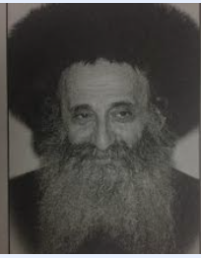
Rabbi Tzvi Hirsch Meisels

Rabbi Tzvi Hirsch Meisels, the Veitzener Rov, zt”l, spent years in the Nazi concentration camps. He relates an unreal story in his sefer, Mekadshei Hashem. On Erev Rosh Hashana 1944, in Auschwitz, the Nazis, ym”sh, rounded up 1,400 young boys and placed them in a separate barrack.
That day, a rumor spread that those boys would all be killed that night in the gas chambers. A “simple” Jew came to Rav Meisels with a question: his son was one of the boys that were to be put to death that night. He said that he had a way to bribe a guard, and get his son out.
However, if he did so, another boy would definitely be taken from the general population to replace him, and would die in his stead. Was he allowed to save his son in such a circumstance?
Rav Meisels writes that he began trembling and crying. “How can I rule on a life-and-death question? I don’t have my seforim here in Auschwitz! I’m not a Sanhedrin!”
The man began crying uncontrollably and said that if the Rav does not clearly say that halachically he can save his son, then it must not be clearly allowed. He added: “I have done what is required of me. I have asked the Rav, and he has not given me a heter (permission). I accept Hashem’s decree upon myself with simcha, and shall not attempt to free my son from certain death.”
The man spent the rest of that fateful Rosh Hashana day talking directly to Hashem. “I have the merit of sacrificing my son on the Altar to You. Although I am able to free him, the Torah does not allow it. May You consider my act like Avrahom’s merit of Akeidas Yitzchak!”

Reprinted from the Parshas Vayeira 5782 email of Reb Mendel Berlin’s Torah Sweets Weekly.

******************************************************************
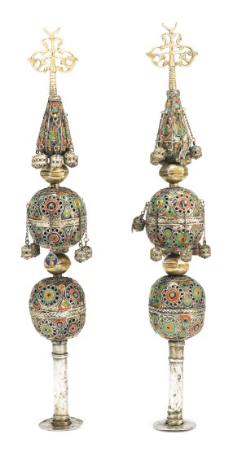
A pair of North African parecel-gilt silver and enamel tall Torah finials (late 19th or early 20th Century) that sold for $12,400 at the December 17, 2013 Sothebys Special Judaica Auction.p

